*Department of Information Systems*

***Systems Design & Development***

**

**Systems Specification for Phumla kamnadi bookinsyssystem**

Team Members

|  |  |
| --- | --- |
| Name and surname | Student Number |
| Caleb Tshinowa | TSHCAL004 |
| Chiko Kasongo | KSNJOS004 |

**Plagiarism Declaration**

We know that plagiarism is wrong. Plagiarism is to use another's work and pretend that it is one's own.

This Systems Specification is our own work.

We have not allowed, and will not allow, anyone to copy our work with the intention of passing it off as their own work.

Full Name: ____Chiko Kasongo____________ Signed:_______CK________ Date: 09/10/2023

Full Name: ______Caleb Tshinowa_________ Signed:______CT_________ Date: 09/10/2023

**Table Of Contents**

**1.** 1

1.1. 1

1.2. 1

1.3. 3

**2.** 4

2.1. 4

2.2. 5

2.3. 5

**3.** 7

3.1. 7

3.2. 8

**4.** 9

**5.** 10

**6.** 11

6.1. 11

*6.1.1.* 11

*6.1.2.* 13

6.2. 14

*6.2.1.* 14

*6.2.2.* 16

**7.** 17

7.1. 17

7.2. 17

7.3. 17

7.4. 17

**8.** 18

**9.** 20

9.1. 20

9.2. **Error! Bookmark not defined.**

9.3. 20

9.4. 21

9.5. 22

# Introduction

## Overview of Specification

This document represents the system specification for the development of the Booking system for PHUMLA KAMNANDI hotel group. The project was initiated to serve as a response to the growing demand of a modern booking and billing process to replace the older process in place, as highlighted in the business case which identified the need of creating a software system that would address the issues faced by the hotel.

The project is currently in the design and analysis phase where the different requirements are gathered, the specific needs and functionalities of the systems identified and the architectural design related to the system’s structure and layout is implemented. As a result of this some adjustments and refinements have been made to the project to ensure that it stays on track to meet the objectives.

Following this the project will transition into the development phase, where the development of the booking system will begin. The system will have to be tested rigorously by using unit testing and user acceptance testing to ensure that the system aligns with the requirements specified.

## Context & Scope of System Specification

The PHUMLA KAMNANDI hotel group, originally founded in 2022 is a small hotel management group in South Africa currently managing 30 hotels around the country. Each hotel operates independently from one another and has their own context. One of the primary issues raised was the handling of the reservations and booking, with some hotels operating on manual register, and an unstandardised system, resulting in loss of income and unsatisfied guests. As a response to these issues, the group undertook the strategic initiative of developing a booking system that would provide an integrated platform for smooth booking management, real time availability, billing, enhancing the guest experience and adding operational efficiency.

The scope of the booking system will include the booking management dealing with reservation creation, room allocation, guest check-in and tracking room availability. it will integrate a billing process as well to generate invoices and facilitate payment. A user interface will be also integrated to ensure ease in using the platform. and finally reporting and analysis to help with data driven decision-making , monitoring performance and planning.

Implementing this system successfully will result in improvement in customer satisfaction, increased revenue through an optimized booking process, reduced errors and enhance the overall efficiency of the booking process.

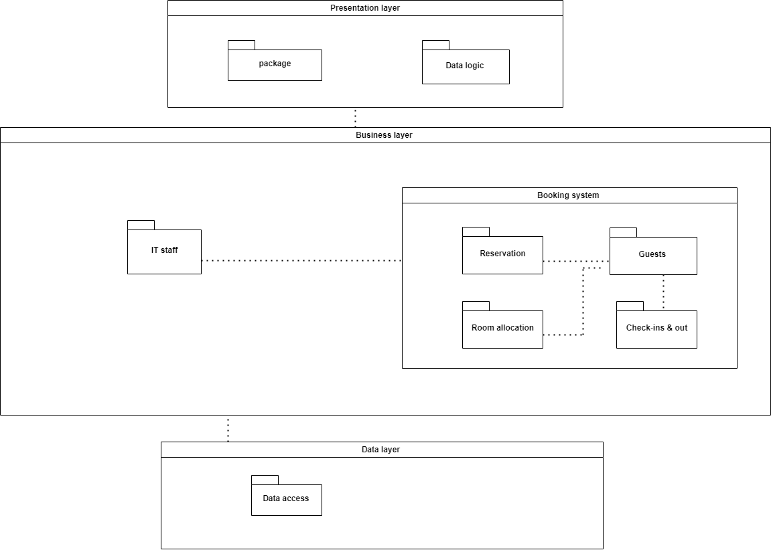

## Design Assumptions & Constraints

To successfully design and develop the PHUMLA KAMNANDI booking and billing system it is important to have a good understanding of the system requirements as well as acknowledging the conditions , limitations and expectations influencing the design process. The following lines will outline the design assumptions and constraints that shaped the system’s architecture and functionality.

**Assumptions:**

-Hardware : It is assumed that the hotel operates on a hardware infrastructure that meets the performance requirements for the system to operate efficiently.

- Security: It is assumed that appropriate security measures are implemented, such as firewall, intrusion detection and identity access management. It is also assumed that they are handled by IT professionals.

- User training: It is assumed that hotel staff and guests have received adequate training and support before enabling them to use the system effectively.

-Network connection: There should be a stable and reliable network connectivity available at the hotel location.

**Constraints**

* Financial constraint: Since the project will operate within the predefined budget constraint, it may impact the any addition of features and functionalities
* Privacy: The system must adhere to data privacy and
* Scalability: The system must be able to handle increased booking loads as the hotel expands
* Maintenance and support: The system must consider maintenance and supports to ensure that the updates , bug fixes and enhancement can be applied without disrupting the hotel operations

# User Interface & Dialogue Design

## Interface Flow Diagrams

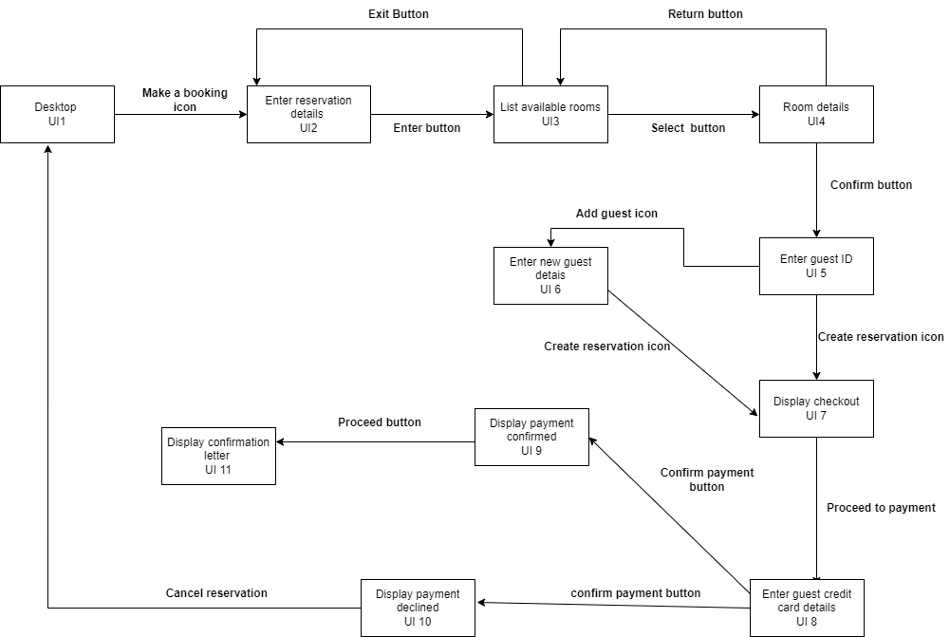

## Screen Standards

## Detailed Screen Layout

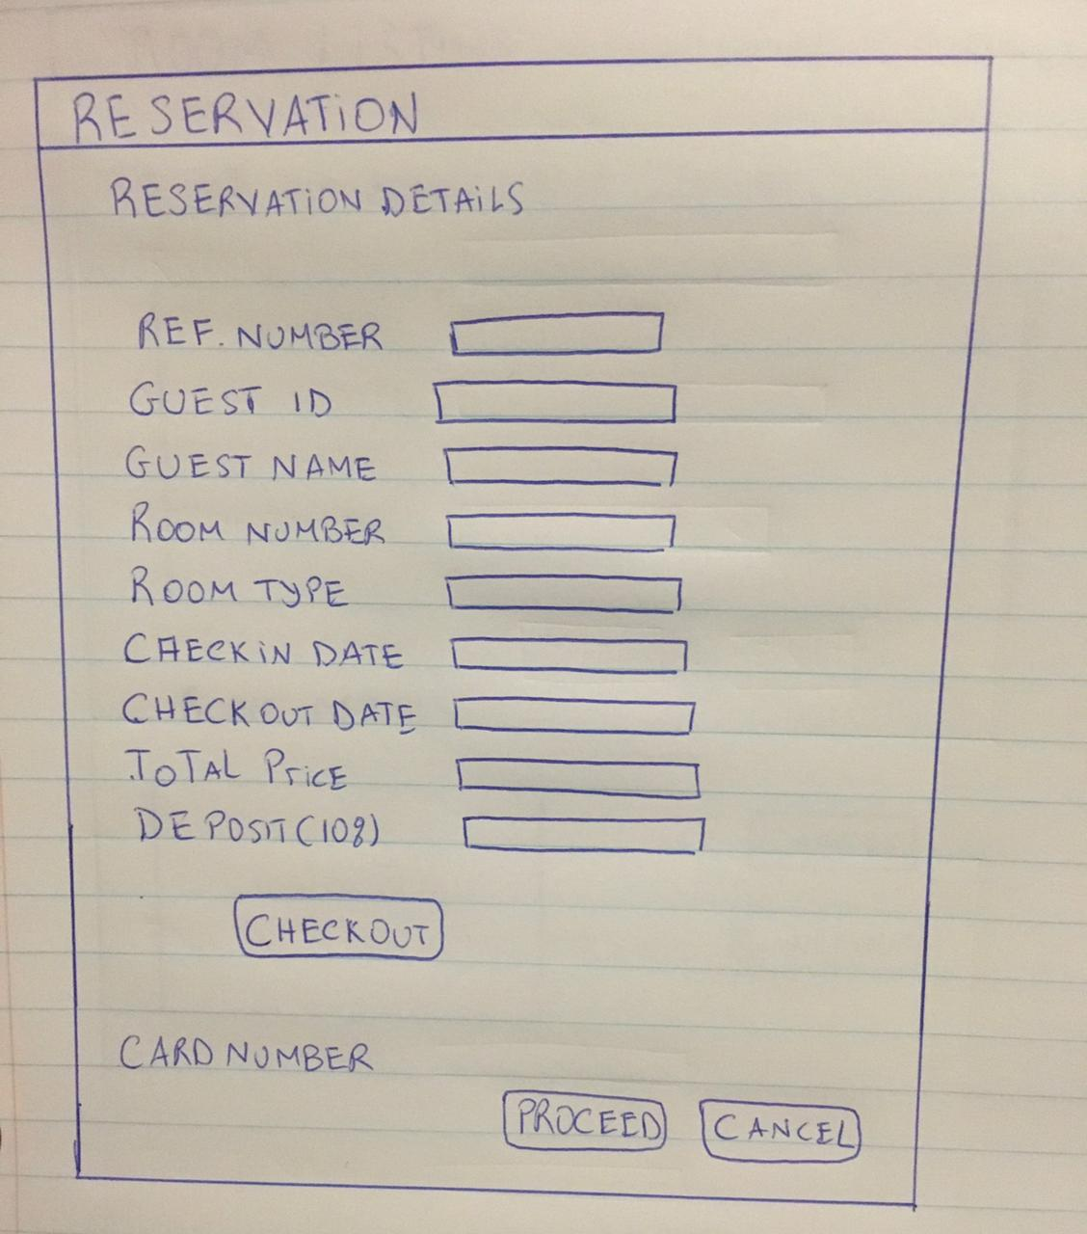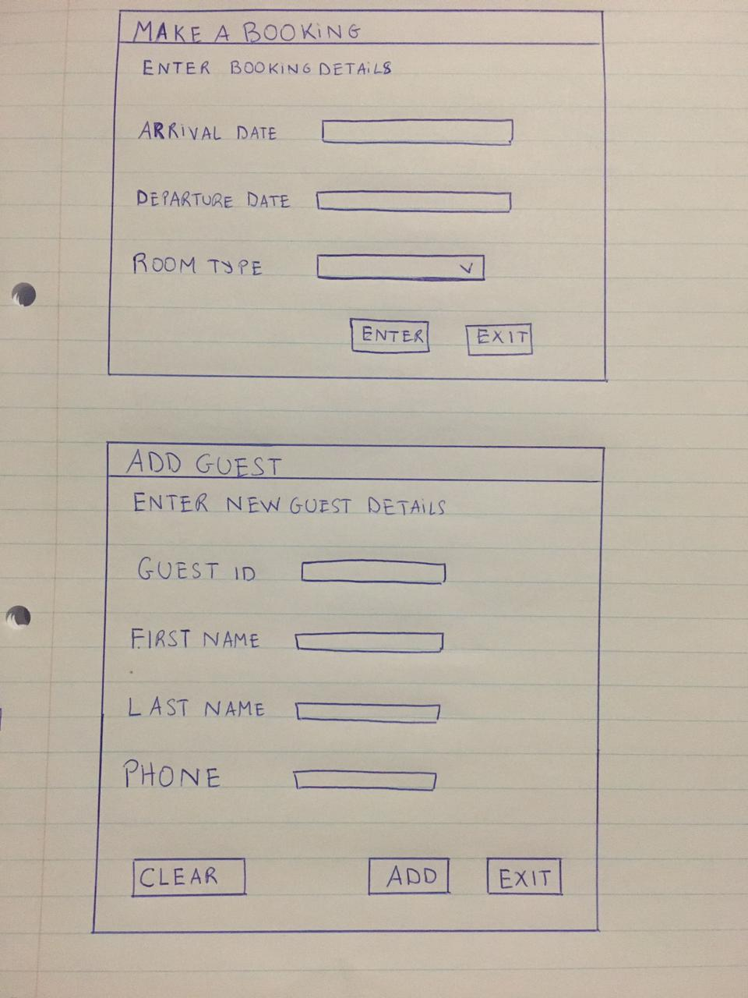

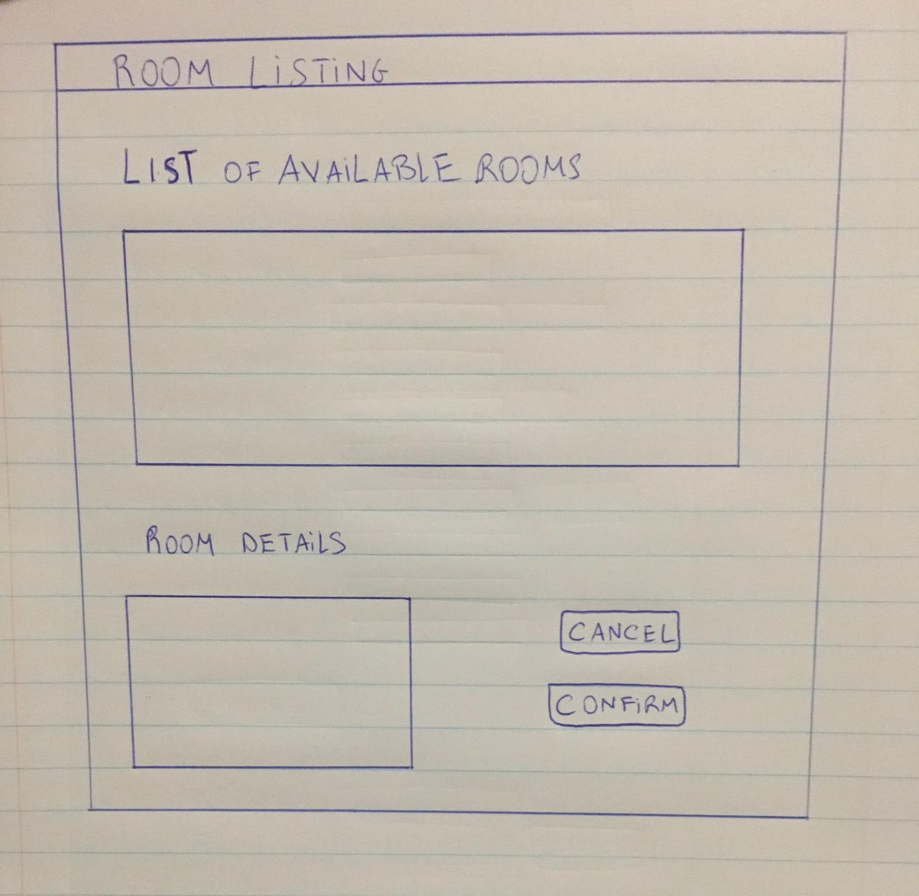

# Design Sequence Diagrams

## Design Sequence Diagram of make a booking use case

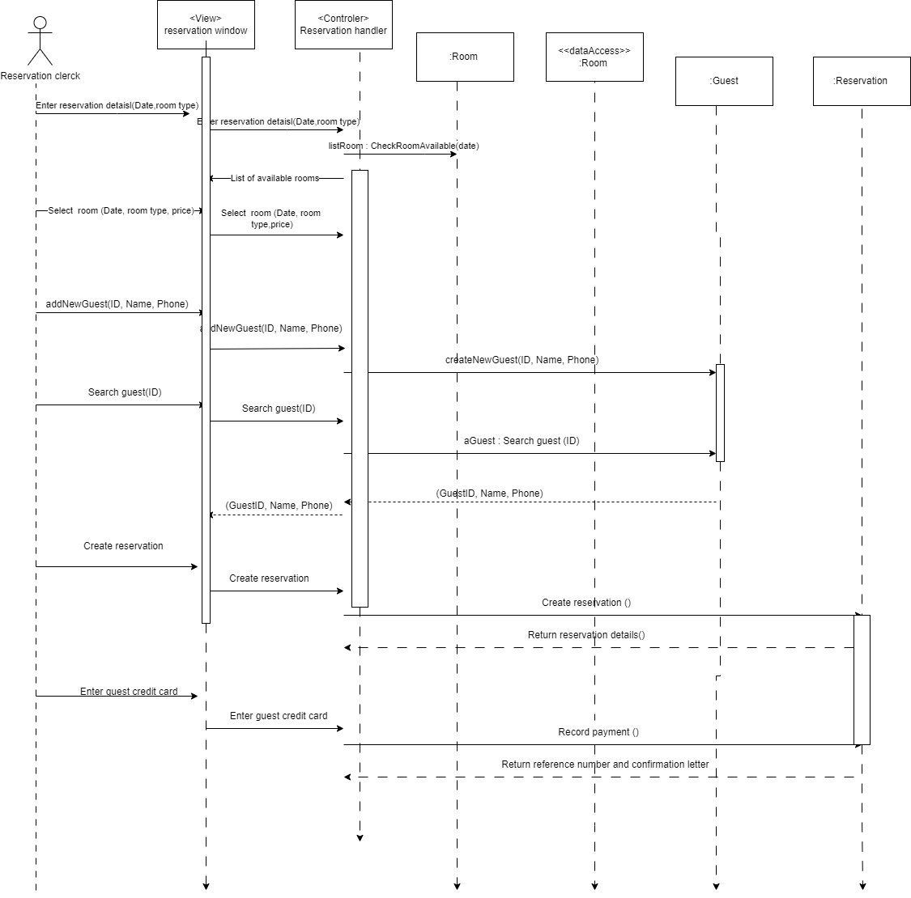

## Design Sequence of Change a booking use case

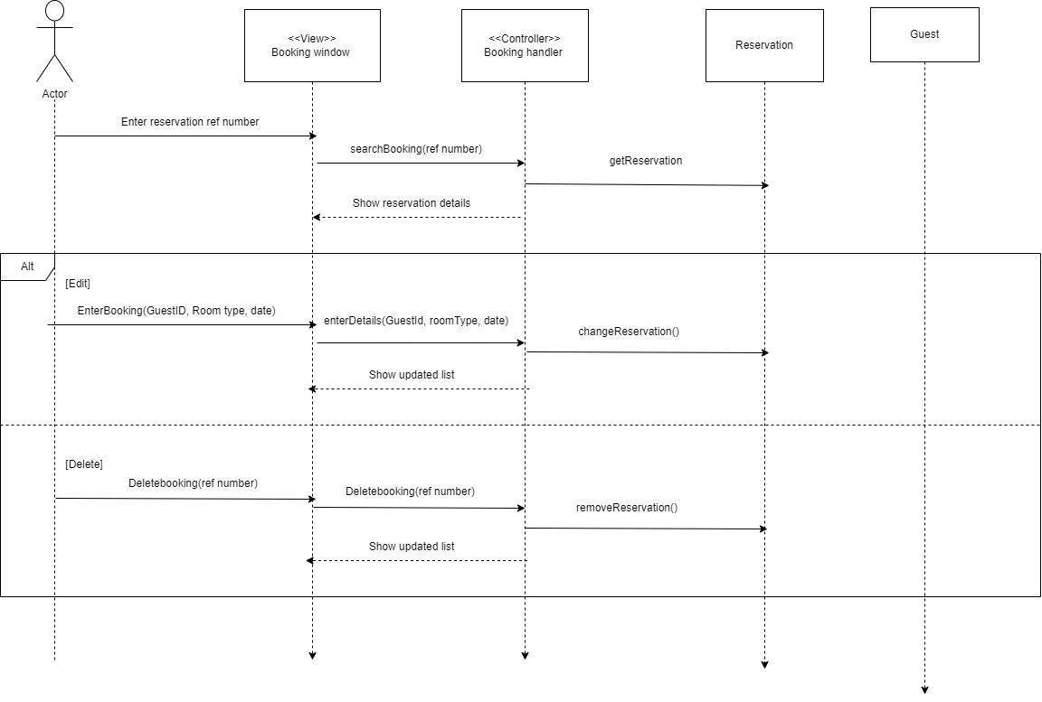

# Design Class Diagrams

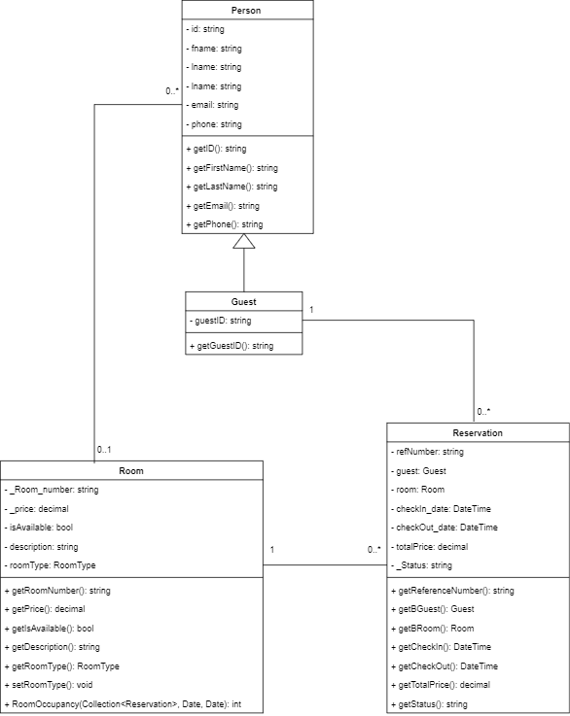

# Entity Relationship Diagram

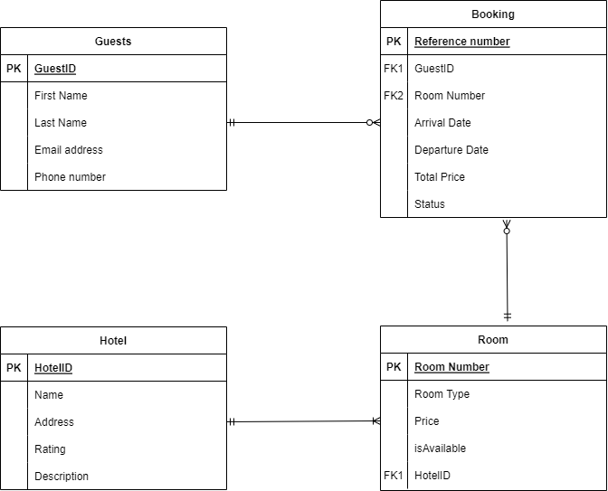

# Report Design

## Report 1

The first report generated will be a summary report that shows the occupancy level for the period ranging from the 1st to the 31st of December 2023. This report will be a pivotal one for the hotel group as it will provide management with a snapshot of the hotel;s occupancy status, allowing them to monitor and optimize the room availability, forecast future demand to make pricing decisions eventually impacting the hotel’s revenue.

### Detailed Output Requirements

|  |  |
| --- | --- |
| Report type & ID | The first report will be a summary as it is most appropriate for the occupancy level  ID: Summary of Occupancy level December. 1.1 |
| Report Objectives | * To capture the overall occupancy level for each room for the month of January |
| Audience | Senior management, department head, sales and marketing team, guests, investors |
| Content | * The reporting will be on the monthly rooms occupation rate of the hotel, showing the average occupation rate of each room then adding them up to generate a final one for the hotel in general. |
| Layout | * A line graph that will contain general trends of room occupancy level. * Table for room occupancy level showing average room occupancy and total average room occupancy. |
| Selection | -Reservation systems, room check-ins and check-outs. |
| Sequence |  |
| Comparison |  |
| Grouping |  |
| Media to be used | -Graphs: General trends of room occupancy level for the month of December  - Tables: Shows average room occupancy level per room and total average room occupancy level for all rooms. |
| Frequency, timing, delivery | * The report must be generated monthly * At the start of every month to report on the previous month’s report. |
| Distribution | * Via email to the hotel managers. |
| Privacy, security & integrity | * The document must be password protected * Signed at the bottom by the report editor for authenticity. |

### Report Layout

Summary of room occupancy level for the Month of December

**Date of information:** 01 Dec- 31 Dec 2023

**To:** Senior Management,Department head, Marketing Director

**Objective of the report:**  The aim of the report is to capture the room occupancy level for the month of December

Figure 1: Table containing average room occupancy per room and total average room occupancy overall.

|  |  |  |  |
| --- | --- | --- | --- |
| **Room number** | **Occupancy** | **Availability** | **% Average** |
| 1 | 24 | 31 | 77.41935 |
| 2 | 26 | 31 | 83.87 |
| 3 | 25 | 31 | 80.64 |
| 4 | 28 | 31 | 90.322 |
| 5 | 27 | 31 | 87.09677 |
| 6 | 30 | 31 | 96.77 |
| 7 | 24 | 31 | 77.41 |
| 8 | 29 | 31 | 93.54 |
| **Total** |  |  | **85.8871** |

## Report 2

The second report generated will be a summary report of the total revenue per room and for the hotel overall for the month of December. This report will be important for financial monitoring, performance evaluation, pricing strategies and marketing

### Detailed Output Requirements

|  |  |
| --- | --- |
| Report type and ID | Summary report on total hotel revenue for the total hotel revenue for the month of December |
| Report Objectives | To capture the overall revenue generated by the hotel including rooms revenue, and other revenue such as events organization, sponsorships, travel agency |
| Audience | -Hotel management  - Marketing department  - Investors |
| Content | The report will contain all revenues generated by each room’s category and other revenue source |
| Layout | * two tables , one showing the revenue generated from room servicing and the other from other activities |
| Selection | * Guest invoices * Account * Point of sales |
| Sequence |  |
| Comparison |  |
| Grouping |  |
| Media to be used | * Two tables and one graph will be used for transmitting the information contained in the report. |
| Frequency & timing | * The report should be delivered at the end of the month to allow management to make decisions on future activities based on past performance. |
| Distribution | * Email * Conferences * Documents and reports |
| Privacy ,security and integrity | * Documents should be password protected * The documents should be stamped and signed for authentication. |

### Report Layout

Summary of room occupancy level for the Month of December

**Date of information:** 01 Dec- 31 Dec 2023

**To:** Senior Management, Department head, Marketing Director

**Objective of the report:**  The aim of the report is to capture the total revenue per room types for the month of December

Figure 1: Table containing the revenue per room type for December 2023

|  |  |  |  |  |
| --- | --- | --- | --- | --- |
| Room type | Price | Day occupied | Revenue generated |  |
| Single | 1500 | 24 | 36000 |  |
| Double | 2800 | 21 | 58800 |  |
| Suite | 3200 | 24 | 76800 |  |
| Presidential | 3400 | 14 | 47600 |  |
|  |  |  | 219200 |  |

# Input-Output Standards & Controls

## Formalised Outputs:

The formalized screen forms of output included are:

* On screen display, which includes all the key information regarding the booking such as the name, room type, contact details, date of stay

## Built-In Validation to Ensure Requirements are Met

The built in validation included are :

-Data type validation

-Format validation

-Range validation

-Date and time validation

## Input Integrity Controls

These are security measures implemented that will prevent invalid data from entering the system and ensure that they are accurate.

The system will check if the valid date of stay has been chosen to avoid errors , it will check if the personnel details of new guests are captured correctly. The system also makes sure that the selected rooms are available for for the specified dates

## Output Integrity Controls

Output integrity are security measures that are implemented to ensure that the output data arrives at the proper destination and is complete and current.

The system includes an error message that pops out in case of an issue occurring during the process.

# Implementation Plan

Implementation plan for the Booking system of PHUMLA KAMNADI hotel

**Phase:** Implementation of the booking system

**Responsibilities**

**Project manager:**  Responsible of the overall project management and development

**Backend developers:**  Responsible of Database development

**Frontend developers:**  Responsible of UI design

**Testing team & quality assurance:** Responsible for the testing and quality of the project

**Duration:**  10 weeks

First 2 weeks

The main tasks in this phase are :

- To define the scope and objective of the implementation phase

- Develop a detailed project plan

- Assign responsibilities to each teams

From 3rd to 4th week

The main tasks here will be :

- Finalize the database for the storing system

- Develop APIs for the process and retrieval of data

- Conduct a test of the backend components

From 5th to 7th week

Main tasks here are :

* The design and development of the user interface

From 7th week onward

Main tasks :

- Identify any bug that needs to be fixed

- Develop a user guide and documentation

- Perform the required testings such as unit testing, integration testing and user acceptance.

# Test Plan

## Test Environment

The required infrastructure to conduct the tests are :

-Hardware components: there should be physical servers replicating the production environment.

-Networking components: A good access to the internet is required.

-Testing tools: There should be software to manage the test cases, execution and reporting.

- Security testing infrastructure: There should be tools in place to identify any vulnerability and weakness in the security of the software.

-Backup and recovery: There should be regular backups of the test environment’s configuration, data and settings to restore in case of failures.

## Test Approaches

The first type of test to be performed will be. Here each individual component will be tested isolatedly before being integrated into larger modules. These testing procedures will ensure that each unit will perform as expected and will adhere to the design specifications. Both manual and automated approaches will be used.

Besides unit testing, another test that will be implemented is integration testing , which tests the interactions and the data flow between the different components of the booking system. and ensures that all the system modules work together and data is correctly passed between them.

The third approach will be to use the user acceptance testing, which is a test that is conducted to validate that the system meets the requirements and expectations and aligns with the required scenario.

## Problem Tracking (Test Cases)

Below is an example of how a problem tracking system can be implemented in case of a bug in the booking system

**Problem tracking**

**Project:**  PHUMLA KAMNADI BOOKING SYSTEM

**ID:** A-01

**Priority:**  High

**Status:**  Open

**Assigned to :**  Senior developers

**Reported by:**  Testing team

**Date reported:**  09/10/2023

**Description:**  When the user clicks on the proceed button on the reservation screen nothing happens, it is unresponsive.

**Steps to procedure:**

* Launch the booking system
* Navigate to the reservation screen
* Click on the “Proceed button”

The expected behavior after this is that the user should be taken to the booking form to complete the process, but the actual behavior observed is that the button doesn’t respond.

**Comments**

The testers confirm the issue and inform the developers who will start investigating the issue until they find the cause of the problem and fix it.

## Test Schedule

|  |  |  |  |  |
| --- | --- | --- | --- | --- |
| Milestone | Deliverable | Effort | Start date | End date |
| Project kick off | Test plan | 1 week | 31/07/2023 | 05/08/2023 |
| Test environment set-up | Test environment | 2 weeks | 21/08/2023 | 01/09/2023 |
| Test case design | Test case documents | 3 weeks | 28/08/2023 | 18/09/2023 |
| Test reporting | Test closure, report | 1 week | 09/10/2023 | 13/10/2023 |